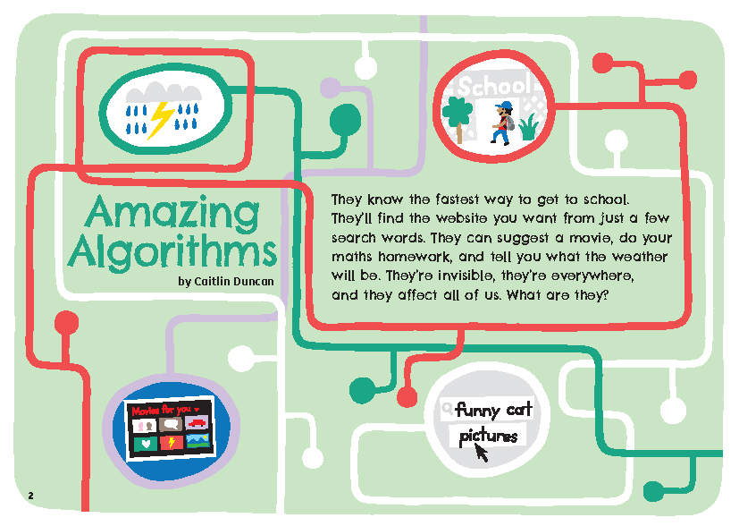
Connected
Level 2
2018

Amazing Algorithms
by Caitlin Duncan

Overview
This article introduces and explains the concept of algorithms. It supports understanding of this abstract concept by providing concrete examples from everyday life, mathematics, and computer programming.
A Google Slides version of this article is available at www.connected.tki.org.nz

Curriculum contexts

TECHNOLOGY: Technological Knowledge: Technological systems  Level 2 – Students will understand that there are relationships between the inputs, controlled transformations, and outputs occurring within simple technological systems.  Computational thinking for digital technologies: Progress outcome 1  In authentic contexts and taking account of end-users, students use their decomposition skills to break down simple non-computerised tasks into precise, unambiguous, step-by-step instructions (algorithmic thinking). They give these instructions, identify any errors in them as they are followed, and correct them (simple debugging). | Key technology ideas  - An algorithm is a list of steps that solves a problem or completes a task.  - An algorithm for one problem can be used for similar problems.
ENGLISH: Reading  Level 2 – Ideas: Students will show some understanding of ideas within, across, and beyond texts. | Indicators:  - uses their personal experience and world and literacy knowledge to make meaning from texts  - makes meaning of increasingly complex texts by identifying main ideas  - makes and supports inferences from texts with some independence.
ENGLISH: Writing  Level 2 – Structure: Students will organise texts, using a range of structures. | Indicator:  - organises and sequences ideas and information with some confidence.
MATHEMATICS and STATISTICS: Number and Algebra: Equations and expressions  Level 2 – Students will communicate and interpret simple additive strategies, using words, diagrams (pictures), and symbols. | Key mathematics ideas  - Algorithm is a term used in maths to refer to a certain way of working out an answer (for example, a written vertical algorithm is used to add, subtract, multiply, or divide).

The New Zealand Curriculum

Technology

Meeting the literacy challenges

While texts at this level should contain some abstract ideas, this text is entirely structured around the abstract concept of algorithms. This concept is described and supported with written explanations, familiar concrete examples, diagrams, illustrations, comics, and infographics. The text includes activities and questions that will prompt active engagement with the text.  The language is clear and straightforward, but the text is quite long. It includes multiple sections, each focused on a different aspect of algorithms. Students will need to track information and ideas across paragraphs and sections. They will need to integrate the ideas in the text with ideas from the visual images, the questions, and the activities. The activities require them to follow the steps in procedural text. | The following strategies will support students to understand, respond to, and think critically about the information and ideas in the text. It may be appropriate to use all or only one or two of these strategies, depending on your students’ literacy knowledge and skills. You are encouraged to reword the suggested questions that will best suit your learners’ strengths and needs.  You may wish to use shared or guided reading, or a mixture of both, depending on the reading expertise of your students and the background knowledge they bring to the text. However, it is suggested that the initial reading should be shared to support students to process the abstract concepts and track the ideas across the text.  After reading the text, support students to explore the activities outlined in the following pages.

INSTRUCTIONAL STRATEGIES

Finding the main ideas  Tell the students this text is all about algorithms. Explain to them that we use algorithms every day and that they are like instructions. Have the students read the title and introductory text and SCAN the article to predict what algorithms are used for. The author asks the question “What are they?” Let’s find out!  MODEL how to create a Frayer Model, a type of graphic organiser that explores a concept’s definition, key characteristics, examples, and non-examples. Explain each of the categories. Read pages 2 and 3 together and model how you find information for the definition of algorithm. Have the students work in pairs to find information for each of the other three categories. If students have trouble thinking of examples or non-examples, you could PROMPT them to think about the difference between cooking something from a recipe or from memory. Have the students work in groups or pairs to create their own Frayer Models. Read through the text together, section-by-section. Pause after each section to discuss, add to or refine the students’ definitions. After the reading, they can DISCUSS and COMPARE their definitions as a class. If they still have questions about what an algorithm is, they could investigate further using some of the resources in the resource links section.  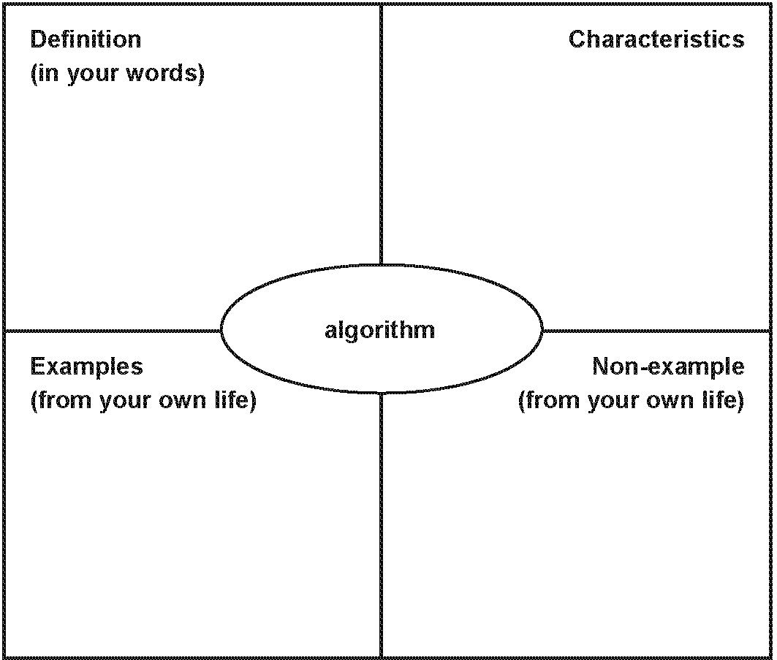 | Using design features for deeper understanding  PROMPT the students to look closely at the illustrations on page 3.  What do these illustrations show us? Why are they there? How do they connect to the text? Can you show me the specific parts of the text that they are illustrating?  Talk me through the steps in the algorithm for the computer game. How does this relate to the pictures on the right? What does the person playing the game see on their screen? What stays “behind the scene”? Explain that the word for this is ‘coding’.  Do any of the pictures contain information that you could add to your definition of an algorithm?  Listen in to the students’ discussions as they develop their Frayer Model definitions, checking that they are reading the visual imagery as well as the written text.  Evaluating and using the text features  EXPLAIN that the writer has taken what could have been quite a dry topic and has found lots of ways to get people interested. Have the students IDENTIFY some of the ways the writer has done this as they read (for example, the direct address to the reader, the activities and questions, and the conversational and upbeat tone). Make sure the students notice the invitations to think through questions, follow through the steps in diagrams, or try out activities. Encourage them to respond to these invitations. After the reading, PROMPT them to reflect on how this active engagement with the text helped them to understand a topic that they may otherwise not have enjoyed.  How well did you understand the main ideas before you responded to the questions or tried out the activities?  Why do you think responding like this helped?  How might you use this in your own writing?

Meeting the literacy challenges

Have the students move into groups. Tell them that each group is to select a diagram or activity and use it to teach the rest of the class. They will need to think about the learning purpose and what they will do to achieve their purpose. For example, if they choose “Sort it out” on page 7, their process could include:  - checking they understand the main idea  - explaining the main idea to the class  - inviting the rest of the class to respond orally to the questions in the text  - handing out small items (such as Lego pieces) that pairs of students could sort into groups  - having the pairs write an algorithm to explain how to create their patterns  - having the pairs swap each other’s instructions to see if they can re-create the patterns.  DISCUSS what the students gained from these activities, clarifying the idea that we often understand a concept better when we have to do something with it and explain it to others.  How could we apply this idea to other texts we read?  Some of us found X difficult to read. Is there an activity we could have tried to help us understand what we were reading?  Is this an idea we could apply to our own writing? | Dealing with unfamiliar vocabulary  The article focuses on algorithms, but as it does so, it incorporates other words that the students need to know and understand. Have the students IDENTIFY those words and DISCUSS which of them they want to understand further. As a class, take them through the process of creating a definition for one of the words, using the Frayer model. They could move back into groups and create a definition for other words. The definitions could then be shared, critiqued, and improved before being compiled into a class or school resource. This resource can continue to be developed and refined over time. Selected examples could be posted around the school or on the school website to familiarise people with the language of digital technologies.

TEACHER RESOURCES

Want to know more about instructional strategies? Go to:  - http://literacyonline.tki.org.nz/Literacy-Online/Planning-for-my-students-needs/Effective-Literacy-Practice-Years-1-4  - “Engaging Learners with Texts” (Chapter 5) from Effective Literacy Practice in Years 1 to 4 (Ministry of Education, 2003).  Want to know more about what literacy skills and knowledge your students need? Go to:  - http://nzcurriculum.tki.org.nz/Assessment/Reading-and-writing-standards  - http://www.literacyprogressions.tki.org.nz | We have retained the links to the National Standards while a new assessment and reporting system is being developed. For more information on assessing and reporting in the post-National Standards era, see:  - http://assessment.tki.org.nz/Assessment-and-reporting-guide

Reading standard: by the end of year 4
The Literacy Learning Progressions
Effective Literacy Practice: years 1–4

Illustrating the key ideas

TEACHER SUPPORT
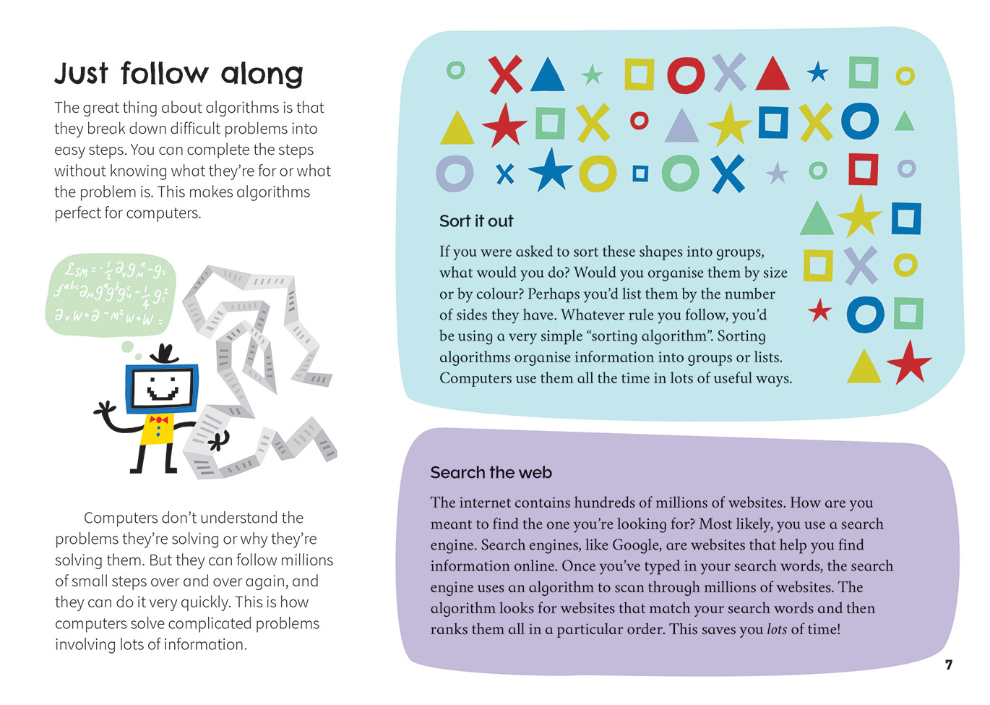  Algorithms are step-by-step instructions to solve problems or complete tasks. | Decomposition skills are used to break down simple non-computerised tasks into step-by-step instructions.
There are relationships between the inputs, controlled transformations, and outputs within simple technological systems.  . |  | [Grab your reader’s attention with a great quote from the document or use this space to emphasize a key point. To place this text box anywhere on the page, just drag it.]

Learning activities – Exploring technology
and mathematics and statistics

Activity 1 – Creating our own algorithms  Follow the suggestions for introducing algorithms provided by Australia’s Digital Technologies Learning Hub. In this activity, students create a sequenced list of instructions for carrying out an everyday task, such as making a sandwich or getting dressed. Use the examples to check that the students understand the importance of getting the sequence right.  What would happen if I put my shoes on before my socks? Or my jumper on before my T-shirt?  What have we learnt from this that would be useful to remember the next time we write an algorithm?  Extension  Have the students create a game or puzzle for younger students where success depends on following a simple algorithm.  Activity 2 – How many guesses?  “How many guesses?” is one of a series of teaching and learning activities designed by CS Unplugged. This one demonstrates an algorithm called the “sequential search”. It shows how we can reduce the time spent searching for an answer by removing incorrect answers as we go. It’s a technique that helps us predict how long an algorithm will take. The activity involves statistical thinking, as students make guesses and think about probability. It also involves computational thinking, as it supports students to think about how problems can be solved by an agent, such as a person or a computer. | The following activities and suggestions are designed as a guide for supporting students to explore and extend student content knowledge across the learning areas. Adapt these activities to support your students’ learning needs.  Extension  Present the students with a scenario in which another student has lost their hat. Have them list all of the places the hat might be, such as the playground, the lost property box, their desk, their locker, or their bag. The students are to write a sequential search algorithm for finding the hat. Working in pairs, they can then test that their algorithm works. Afterwards, they could reflect together on any lessons about what is needed to create a successful algorithm.  What have we learnt that would be useful the next time we write an algorithm?  Activity 3 – Coding club  Look on Code Club Aotearoa’s website to find out about a coding club near you. You could invite a volunteer to come and run a session. You could also approach your local high school or college, tertiary institution, or technology business.  If there is already a coding club at your school, the students could share some of their projects and explain how they created them and what they like about coding. They could then support you and/or the volunteer to run a session.  Note that Code Club Aotearoa offers advice and resources for setting up a club. There’s help for accessing volunteers and there’s even teacher training. If your students are interested in having a club of their own, this is a great place to start.

RESOURCE LINKS

School Journal  “As Easy as One, Two, Three”, School Journal Level 2, June 2018  Other sources  Code Club Aotearoa: https://codeclub.nz/  WhatIs.com – algorithm: http://whatis.techtarget.com/definition/algorithm  How Stuff Works – What is a computer algorithm?: https://computer.howstuffworks.com/question717.htm  BBC Bitesize – What is an algorithm?: www.bbc.co.uk/guides/z3whpv4  Digital Technologies Hub (Australia) – Algorithms: www.digitaltechnologieshub.edu.au/teachers/topics/algorithms | CS Unplugged:  How many guesses?: https://csunplugged.org/en/topics/searching-algorithms/sequential-and-binary-search-unit-plan/how-many-guesses/#ct-links  What is computational thinking?: https://csunplugged.org/en/computational-thinking/

